M2 API:
API | End Point and URL | Observation
 | - https://dev.abdm.gov.in/api-hiu/data/notification  - /hiecm/data-flow/v3/health-information/notify  - 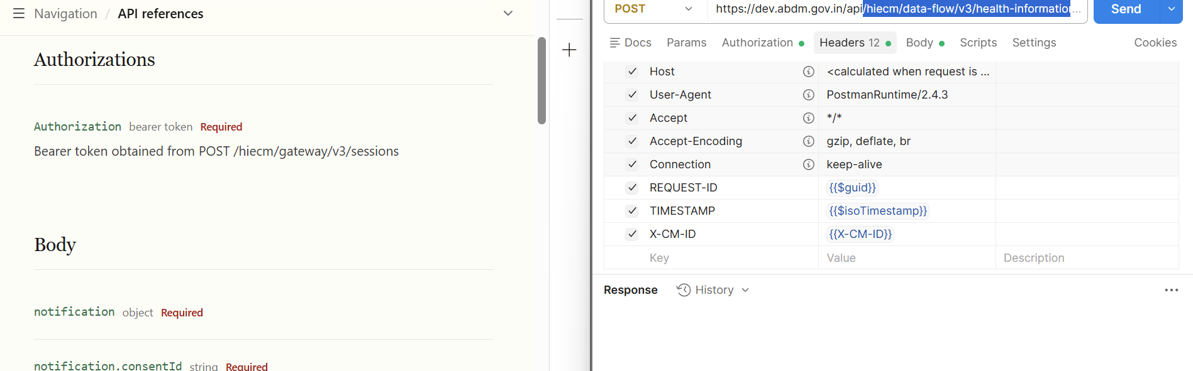 | Need to update below points:  Headers as mentioned in image and link  Curl also needs to update  Not Found
 | - Callback: /api/v3/consent/request/hip/notify | Missing
M3 APIs:
API | End Point and URL | Observation
 | Acknowledge a consent notification, as the HIU | ABDM Developer Portal  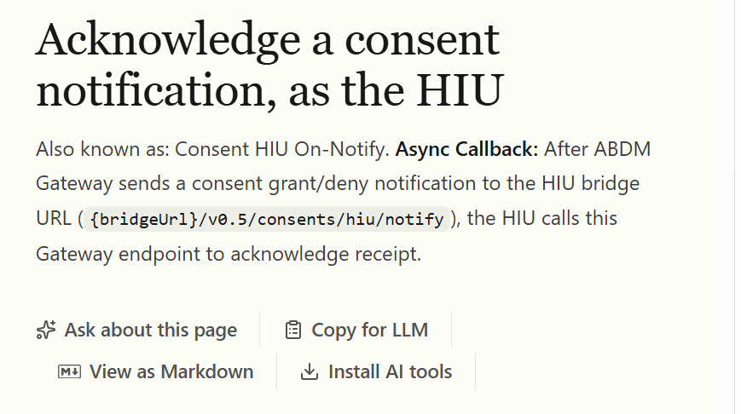 | Change URL ver  V0.5 to v3  Not Found

Suggestions:
- Arrange the API execution flow according to the sequence defined in the Postman collection.
- Consolidate all callback URLs into a dedicated section after listing all APIs.
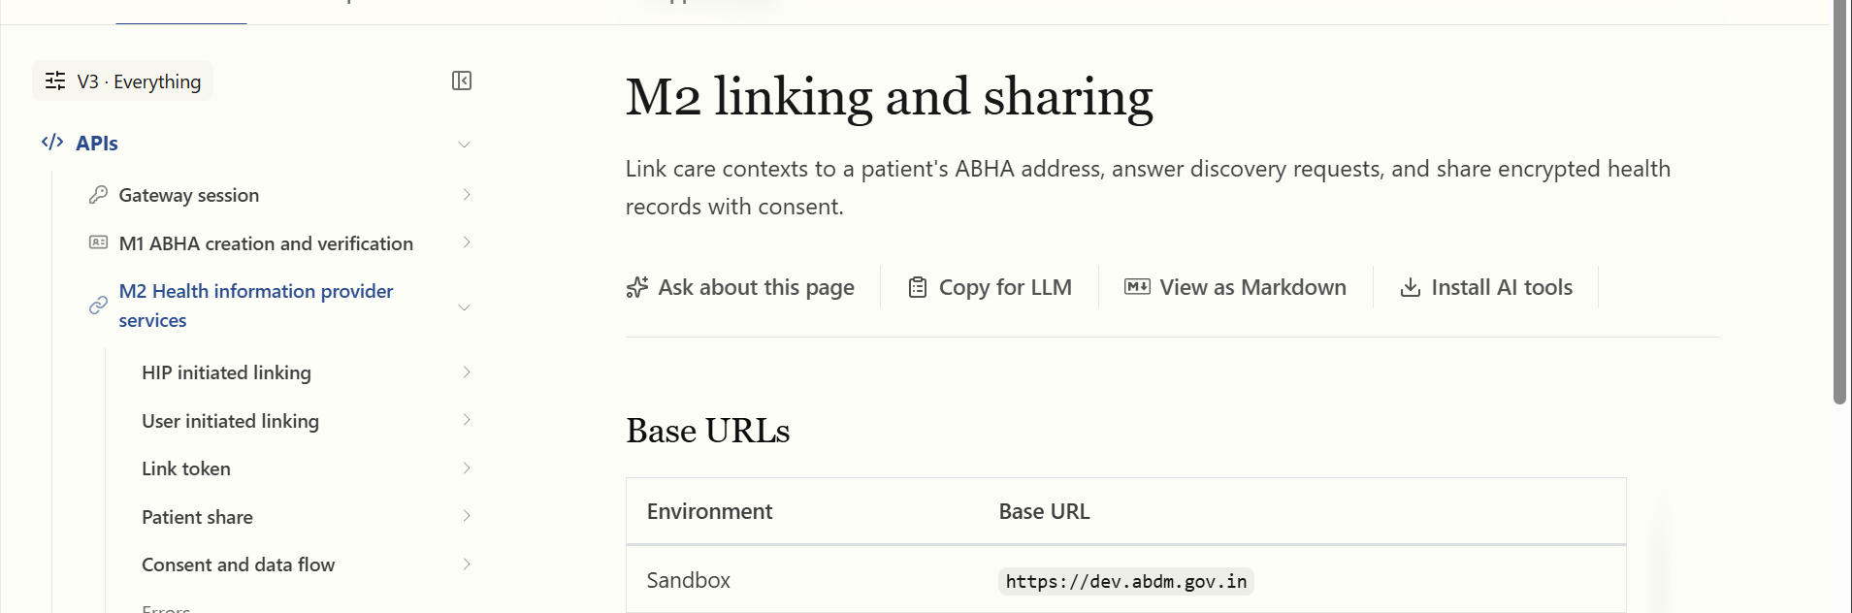
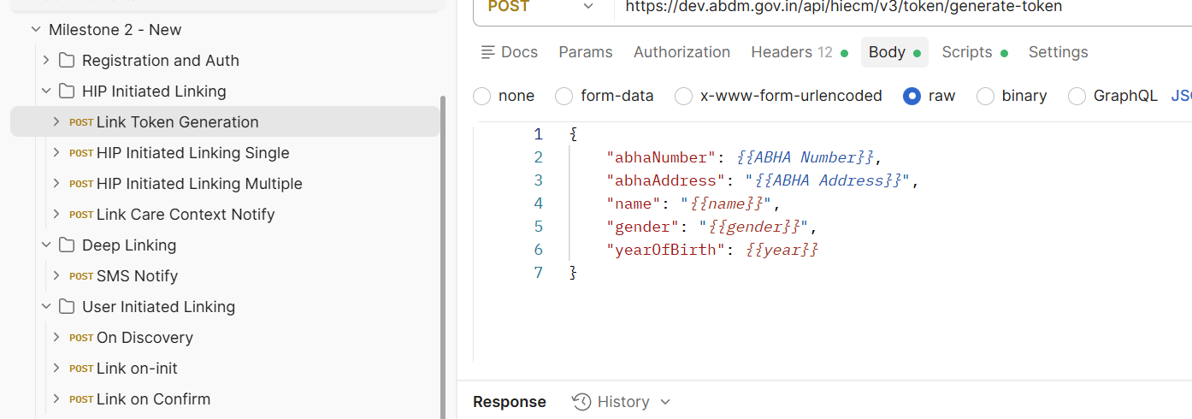
Error code put in one place for M2:

Custom Error Code (New Page)
Content: During ABDM integration, systems may encounter issues across discovery, linking, consent, encryption, and data exchange workflows. This section outlines common errors, their causes, and recommended resolutions to help ensure smooth implementation.
Code | Error
ABDM-1000 | Unable to connect the database
ABDM-1001 | No data found
ABDM-1004 | SMS Gateway is unavailable
ABDM-1006 | Bad Request, invalid request Body
ABDM-1007 | Connection failed due to timeout
ABDM-1008 | SMS service currently disabled
ABDM-1010 | Validation failed
ABDM-1011 | Gateway database unavailable
ABDM-1012 | No records found against the ABHA Address
ABDM-1013 | Invalid ABHA Number
ABDM-1015 | Invalid Response
ABDM-1016 | Invalid TimeStamp
ABDM-1017 | Invalid TransactionId
ABDM-1018 | Share Profile database unavailable
ABDM-1019 | Dependent Service Unavailable
ABDM-1020 | Unknown database
ABDM-1022 | Too many requests
ABDM-1023 | Invalid User
ABDM-1024 | Dependent service unavailable
ABDM-1025 | Invalid ServiceId
ABDM-1026 | Invalid Link Token
ABDM-1027 | You are blocked. Please try again after 24 hours.
ABDM-1028 | HIP is unavailable
ABDM-1029 | Redis server is unavailable
ABDM-1030 | Invalid request ID
ABDM-1031 | Invalid request
ABDM-1032 | Invalid header
ABDM-1033 | HIU is unavailable
ABDM-1034 | Notification service unavailable
ABDM-1035 | Invalid HIP ID
ABDM-1036 | Data does not matched
ABDM-1037 | Counter and Care context count mismatch
ABDM-1038 | ABHA address and Link token mismatch
ABDM-1040 | Invalid HIU ID
ABDM-1041 | Invalid Acknowledgement
ABDM-1042 | Provider Mandatory
ABDM-1043 | ABHA Address does not match with KYC details.
ABDM-1044 | Broadcast Failed
ABDM-1045 | Database Access is restricted
ABDM-1046 | Invalid Purpose
ABDM-1047 | Purpose does not exist
ABDM-1048 | Timeout
ABDM-1049 | Invalid Profile Share Intent Keys
ABDM-1050 | Invalid Profile Share Metadata Keys
ABDM-1051 | Invalid ABHA Number or ABHA Address
ABDM-1052 | Invalid TransactionId or response's requestId
ABDM-1401 | HIP is not available
ABDM-1061 | Consent artefact expired
ABDM-1062 | Consent Not granted
ABDM-1063 | Date Range given is invalid
ABDM-1064 | request with this request id already exists
ABDM-1017 | Invalid TransactionId
ABDM-1109 | ABHA DB service unavailable
ABDM-1108 | Notification DB service unavailable
ABDM-1034 | Notification service unavailable
ABDM-1029 | Redis server is unavailable
ABDM-1201 | IDP Gateway is unavailable
ABDM-9999 | Unknown exception
ABDM-1006 | Invalid combinations of scopes
ABDM-1006 | Bad Request, invalid request Body
ABDM-1056 | This care contexts has been already linked
ABDM-1055 | Invalid HIP Id or PHR Id
ABDM-1056 | Invalid Link Reference Number
ABDM-1057 | Invalid Care Contexts
ABDM-1059 | Invalid Care Contexts count
ABDM-1060 | Invalid Patient Reference Number
ABDM-1061 | Invalid Patient Display
ABDM-1062 | ABHA number mismatch with Link token
ABDM-1063 | HIP Id mismatch with Link token
ABDM-1064 | Request body was missing
ABDM-1065 | Invalid X Auth token
ABDM-1066 | Invalid JWT token
ABDM-1067 | Request body not required
ABDM-1170 | Invalid ABHA address
ABDM-1084 | ABHA address mismatch with X Auth token
ABDM-1085 | ABHA number mismatch with X Auth token
ABDM-1086 | Patient profile mismatch with X Auth token
ABDM-1087 | Duplicate patient share request
ABDM-1090 | Duplicate HIP link request
ABDM-1091 | Duplicate Get links request
ABDM-1092 | Duplicate Link token request
ABDM-1093 | Duplicate Bridge request
ABDM-1094 | Duplicate bridge patch request
ABDM-1095 | Duplicate Bridge service request
ABDM-1102 | Profile information cannot be null
ABDM-1103 | Duplicate Discovery request
ABDM-1104 | Duplicate Init request
ABDM-1105 | Duplicate Confirm request
ABDM-1106 | Duplicate On discovery request
ABDM-1107 | Duplicate On init request
ABDM-1108 | Duplicate On confirm request
ABDM-1109 | Invalid On discovery response
ABDM-1110 | Invalid On init response
ABDM-1111 | Invalid On confirm response
ABDM-1112 | Invalid or already expired consent artefact id
ABDM-1113 | Duplicate health information provider data flow response
ABDM-1149 | Intent type is not supported at HIP end
ABDM-1150 | Bridge API version cannot be null
- ABDM-1401 | HIP is not available
ABDM-1402 | Acknowledgement is not received from HIP
ABDM-9999 | HIP is unable to generate a token at this time. Please try again later.
ABDM-9999 | HIP is unable to process at this time. Please try again later.
ABDM-1030 | Request id not found
ABDM-2500 | No mapping found for
ABDM-2401 | The X Auth token is invalid.
ABDM-2402 | Invalid Timestamp
ABDM-2404 | Invalid Request Id
ABDM-2429 | Too many requests found
ABDM-2501 | Payment status should be : SUCCESS,CANCELED,PENDING,FAIL,REFUND_INITIATED,REFUND_SUCCESS
ABDM-2500 | Authorization header is missing
ABDM-2403 | Invalid X-CM-ID
ABDM-1086 | Patient profile mismatch with X Auth token
ABDM-2406 | Invalid API sequence flow, please follow logical flow
ABDM-2406 | The status is invalid. Please follow the logical status flow or transition.
ABDM-9999 | User not found
ABDM-1024 | Dependent service unavailable
ABDM-9999 | Cannot process the request at the moment, please try later.
ABDM-9001 | No open order against ABHA. Please ensure a minimum of one open order
ABDM-9002 | No registration found at <<hospital name>>. Contact counter support
ABDM-9003 | Hospital services temporarily unavailable. Please try again after some time.
ABDM-9004 | Services disrupted, please try again.
ABDM-9005 | Bank server not responding. Please try again later
ABDM-9006 | Service details mismatch. Please ensure original service ID from HMIS
ABDM-9007 | The Scan and Pay functionality is not enabled at this facility. Kindly contact the hospital administration.
ABDM-1006 | Invalid count, must be 2 digit and ranges between 1 to 20
ABDM-1407 | The ABHA Number associated with this ABHA Address is currently deactivated. Please reactivate it.
ABDM-1006 | Invalid HIType, it must be in Prescription,DiagnosticReport,OPConsultation,DischargeSummary,ImmunizationRecord,HealthDocumentRecord,WellnessRecord,Invoice

